*You represent every single drop of water on Planet Earth. Water is essential for all life on this planet and plays a part in many sectors of every country’s economy. Water as a resource is not distributed equally and is under pressure due to human activity and natural forces.*

**Background information:**

* Although public awareness of the need to better manage and protect water has grown over the last decade, economic criteria and political considerations still drive water policy at all levels.
* Pressures on water resources are increasingly a result of human activity such as urbanization, population growth, increased living standards, growing competition for water and pollution.
* Climate change and the natural variability in the distribution and occurrence of water complicate the sustainable development of water resources.
* Increased demand for food security and poverty relief is increasing the demand for water resources.
* Just 2.5% of Earth’s water is freshwater and about 96% of all liquid freshwater is found underground in aquifers. Aquifers are considered to be “non-renewable” resources because the underground aquifers are either replenished extremely slowly or not at all.
* Many of these aquifers are shared by more than one country and need to be managed in common, but are not.
* The most serious threat to water resources is ecosystem degradation, which often takes place through changes to the landscape (i.e. clearance of forests, conversion of natural land to farmland, urbanization, and growth of cities, building of roads and surface mining. The biggest result of these activities is sedimentation of the water.
* Sedimentation can harm plants and animals by carrying toxic chemicals into the water through run-off, smothering fish eggs and small organisms used by fish as food, raising water temperature and reducing the amount of sunlight penetrating the water.
* Sedimentation also has economic costs by reducing the gallon capacity of water reservoirs, increasing the difficulty of ships to navigate without the risk of running aground, damaging hydroelectric plants and water supply installations and clogging piping and plumbing.
* Around the world, certain lakes, rivers, and inland seas are drying up because too much water is being drawn up an out of them and their tributaries in inefficient ways. Groundwater is being used up very quickly as well. While not as visible, the consequences are equally as devastating in reduced crop yields, diminished river flow, poorer water quality, damage to wetland areas and a gradual sinking of land.
* Growing changes in the availability of water resources will require global political and governmental support to manage them much better.
* Overuse of fertilizers is a major source of water pollution of fresh and coastal waters.
* Water withdrawal from the hydrologic system: 70% is for agricultural use.
* **To grow their daily food, people need 3000 liters of water per person per day!**

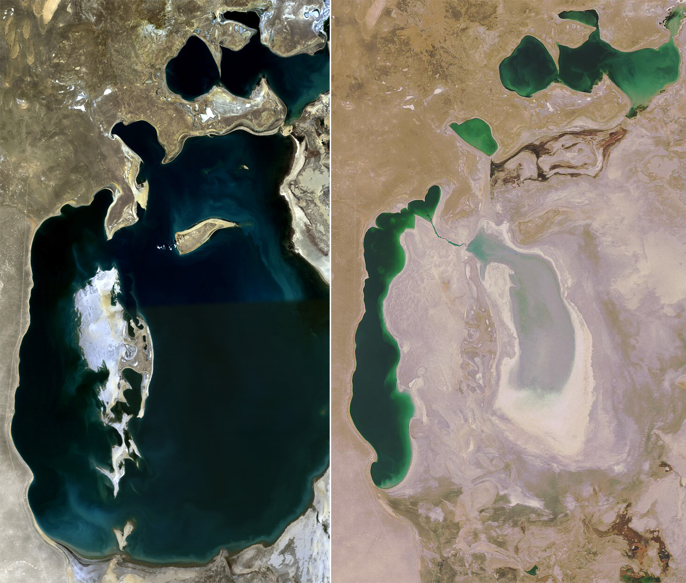

<http://upload.wikimedia.org/wikipedia/commons/9/95/Aral_Sea_1989-2008.jpg>